

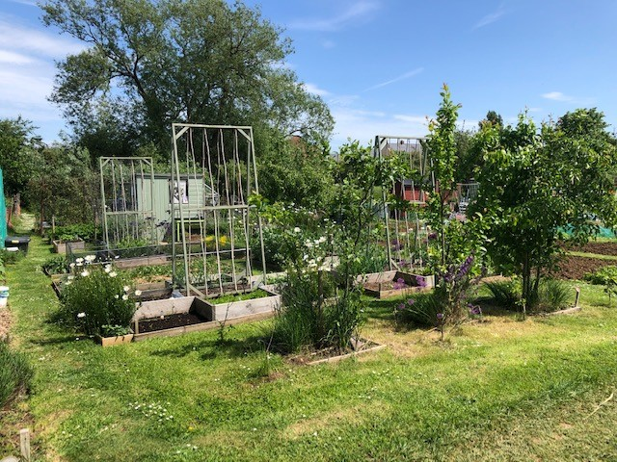

**Melksham Town Council**

**Allotments Terms and Conditions**

**Date Adopted:**

**Date Due For Review: March 2024**

ALLOTMENT RULES

Made by Melksham Town Council in accordance with the Allotment Acts of 1908 - 1950

Throughout these rules the expression “the Council” means Melksham Town Council

1. Any person who, at the time of application to the Council for an allotment garden, is a resident of Melksham Town shall be eligible to become a tenant of an allotment subject to the statutory provision that one person shall not hold allotments acquired under the above mentioned Acts exceeding ½ acre. If a tenant moves out of the area during their tenancy period, then their right to an allotment within the Melksham Town area will cease on the next renewal date.
2. The tenant of an allotment garden shall comply with the following conditions:-
3. The Tenant must use the plot as an allotment garden only and for no other purpose. The Tenant must cultivate the allotment Garden wholly or mainly for the production of vegetable, fruit and flower crops for domestic consumption by themselves or their family.
4. The Tenant must keep the allotment clean, free from weeds and otherwise maintain it in a good state of cultivation and fertility and good condition, and must keep any pathway included in or abutting on the allotment (or, in the case of any pathway abutting on the allotment and any other allotment garden or allotment gardens, the half width of it) reasonably free from weeds.
5. If any Tenant has not adhered to the cultivation rules, a first warning letter will be sent outlining the issue(s) and giving the Tenant 4 weeks to rectify it/them. If no significant improvement has been made a Notice to Quit will be issued to the Tenant, giving them a further 4 weeks to rectify the issue(s) specified. Then if no significant improvement is seen to have taken place the Tenant will be sent a third and final letter informing them that their tenancy has ended. The Council has also the right to seek compensation for the clearing of any plot left in an untidy condition.
6. New Tenants will have an initial 3 month grace period without inspection, after which they are expected to have at least 25% of their plot cultivated. Plots should be 50% cultivated after 6 months, and 75% cultivated after 12 months. If this is not achieved a tenancy may be terminated and the plot re-let. The only exception is for Tenants taking up their tenancy between December and February – this period will be discounted.
7. The Tenant must not cause or permit any nuisance or annoyance to the occupier of any other allotment garden, or obstruct or encroach on any path or roadway set out by the Council for the use of the occupiers of the allotment gardens.
8. The Tenant must at all times during the tenancy observe and comply fully with all enactment’s, statutory instruments, local, parochial or other bylaws, orders or regulations affecting the Allotment.
9. The Tenant shall not under-let, assign or part with the possession of the allotment garden or any part of it, without the written consent of the Council.
10. The Tenant must not cut or prune any timber or other trees, or take, sell or carry away any mineral, gravel, sand, earth or clay without the written consent of the Council.
11. The Tenant shall not connect a hosepipe to any water tap on the allotment gardens provided by the Council.
12. The Tenant shall not erect any building on the Allotment without the written consent of the Council.
13. The Tenant shall not use barbed wire for a fence adjoining any path set out by the Council for the use of the occupiers of the allotment gardens.
14. The Tenant must not plant any trees or fruit bushes or any crops requiring more than twelve months to mature, without the written consent of the Council.
15. The Tenant must not deposit, or allow other persons to deposit, on the allotment any refuse or any decaying matter, except manure and compost in such quantities as may be reasonably required for use in cultivation, or place any matter in the hedges or ditches in the allotment field which the allotment forms part or in adjoining land. The Tenant must remove all waste generated from the allotment from the site.
16. No bonfires are permitted between 1st April and 30th September.
17. The Tenant shall not bring any dog into the allotment field of which the allotment forms part, or cause one to be brought in, unless the dog is held on a leash. The Town Council reserves the right to refuse admittance to any dog causing a nuisance.
18. No livestock of any kind, expect as specifically allowed by statute, shall be kept on the allotment garden.
19. The Tenant must only use non-residual weed-killers to prevent risks to other allotment gardens and local residents. All reasonable care must be taken to ensure that adjoining hedges, trees and crops are not adversely affected when addressing weed issues, and should any damage occur this must be made good or replanted as necessary.
20. The Council shall accept no liability in respect of any claim whatsoever arising from personal injury to the tenant or any third party and the tenant agrees to indemnify the Council in respect of any such claim made against it. The Council shall accept no liability to the tenant in respect of any damage to the allotment or theft of any item or structure placed on the allotment.
21. The Tenant shall observe and perform any other specific conditions which the Council consider necessary to preserve the allotment garden from deterioration, and of which notice to the applicants for the allotment garden is given in accordance with these rules.
22. The rent of an allotment garden shall be determined by the Council and be subject to periodic review. The rent shall, unless otherwise agreed in writing by the Town Clerk, be paid yearly on the 1st March in advance for the period 1st March to the last day of February. If a tenancy is commenced in the last quarter of the tenancy year then a pro-rata payment will be due. The Tenancy will be terminated by the Council, giving one month’s notice, if the rent is in arrears for 40 days or more, whether legally demanded or not.

1. Any member or officer of Melksham Town Council shall be entitled, at any time when directed by the Council, to enter and inspect an allotment garden. The Tenant agrees that the Council shall have the right to refuse admittance to the allotment to any person, other than the Tenant or a member of his family, unless accompanied by the Tenant or a member of their family.
2. Any notice required to be given by the Council to the Tenant may be signed on behalf of the Council by the Town Clerk and may be served on the Tenant either personally or by leaving it at their last known address or by letter sent by recorded delivery service addressed to them there or by fixing the same in some conspicuous manner on the Allotment. Any notice required to be given by the Tenant to the Council shall be sufficiently given if signed by the Tenant and sent in a pre-paid post letter to the Town Clerk. The Tenant agrees to inform the Council immediately of any change of his address.

6. The Tenancy will end on the death of the tenant. The tenant’s surviving family may continue with the tenancy, with the consent of the Council and on the signing of a new allotment agreement.

7. The Tenant agrees that any case of dispute between himself and any other occupier of an allotment garden in the allotment field shall be referred to the Council whose decision shall be final.

8. This agreement replaces all previous allotment agreements, if any exist, between the Council and the Tenant, and if not returned signed within 30 days of receipt, serves as 12 months’ notice of termination in accordance with the Allotments Act.