

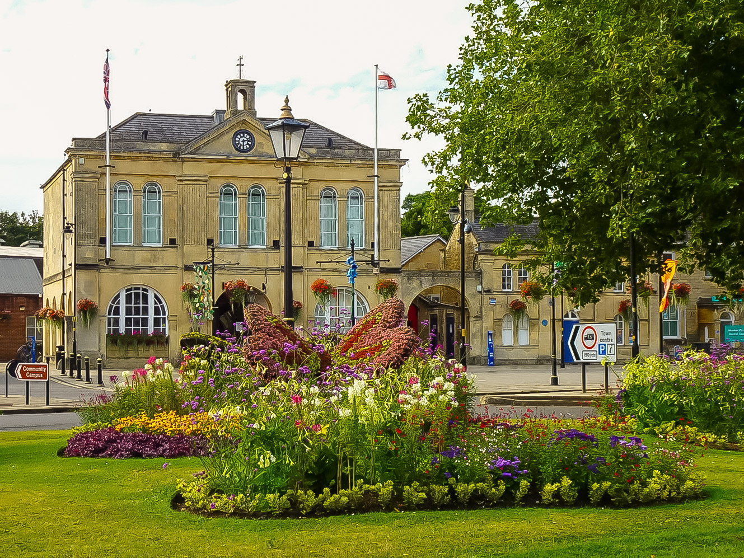

**Melksham Town Council**

**Grants Policy**

**Date Adopted: TBC**

**Date Due For Review: TBC**

**MELKSHAM TOWN COUNCIL**

**GRANTS POLICY**

1. **Introduction**

Melksham Town Council is committed to supporting and strengthening our local community. Each year, we allocate a portion of our budget to a grants scheme designed to bring tangible improvements to the lives of residents and enhance community well-being. These grants aim to support local projects, initiatives that contribute to a stronger, more connected, and vibrant Melksham.

1. **Process**
   1. There are three types of grants available:
      1. **Community Grants:** are for maximum of £1,000 which can be applied for by the 15th of April and the 15th of September and will be paid by means of a bank transfer.
      2. **Facility Hire Grants** enables Melksham Town Council to fund room hire in Melksham Town Hall, Melksham Assembly Hall, or KGV park for a specified (number of) event(s). These must be applied for by the 15th of April or 15th of September. If applying for a Facility Hire Grant, please contact Melksham Assembly Hall [assemblyhall@melksham-tc.gov.uk](https://www.melksham-tc.gov.uk/melksham-town-council-services/venue-hire) prior to making this application to get a quote for the exact amount your event/s would cost.
      3. **Core Grants** are awarded annually for a maximum of four years. This offers financial assurance to larger organisations operating within Melksham Town. Applicants must demonstrate how their work meets the strategic aims of Melksham Town Council. Core Grant recipients are selected at the discretion of Melksham Town Council though an application process. Monitoring forms for Core Grants must be received by 1stth October of each year to be considered in the Melksham Town Council’s budget for the following financial year. Core Grants will be paid by bank transfer. Supporting documents will need to be uploaded at the time of application.
   2. Grants will only be awarded to organisations based within the area covered by Melksham Town Council not Melksham Without Parish Council.Applications that do not benefit the community of the Melksham Town Council area will be rejected.
   3. Application forms plus monitoring forms must be completed on the Melksham Town Council’s [website.](https://www.melksham-tc.gov.uk/melksham-town-council-services/grants-awards)
   4. All applications will be reviewed by [Community Development Officer](https://www.melksham-tc.gov.uk/melksham-town-council-services/grants-awards) Those which meet the eligibility and content requirements will be referred to the [Finance, Administration and Performance Committee](https://moderngov.microshadeapplications.co.uk/MelkshamTC/ieListMeetings.aspx?CId=145&Year=0) for a decision by elected members.
   5. Application forms will have personal and sensitive information redacted before it becomes a public document as part of the agenda for the [Finance, Administration and Performance Committee.](https://moderngov.microshadeapplications.co.uk/MelkshamTC/ieListMeetings.aspx?CId=145&Year=0)
   6. A representative must attend the [Finance, Administration & Performance Committee meetings](https://moderngov.microshadeapplications.co.uk/MelkshamTC/ieListMeetings.aspx?CId=145&Year=0) in week 2 of the month following application submission, if a representative is not able to attend the application will be deferred. This will enable you to ask and answer any questions to support of your application.
   7. There is no guarantee that grant applications will be successful.

1. **Eligible Organisations**
   1. Below are examples of types of organisations to which grants may be given:

* Charitable organisations
* Youth/Senior Citizen groups
* Sports clubs or arts groups
* Advice organisations
* Organisations assisting the disabled
* Minority groups
* Community buildings
* Community events
* Health/transport/safety groups

1. **Eligibility Criteria** 
   1. To be eligible for funding, an organisation must:
      1. Be a community, voluntary or charitable organisation as outlined above.
      2. Have its own bank/building society current account in the name of the organisation, with two unrelated signatories.
      3. Have at least three members on its management committee/board.
      4. Have a written governing document (e.g., a constitution, memorandum, articles of association, set of rules or trust deed).
      5. Have an adopted Safeguarding Policy if working with children and young people and/or vulnerable adults.
      6. Have an adopted Equal Opportunities Policy or Statement.
      7. Have an adopted Environmental Policy (or evidence of its environmentally responsible and sustainable practices).
      8. Show evidence that their project/service is required in the area covered by Melksham Town Council and that it has community support.
      9. Show evidence that their project/service will benefit the community and/or individuals based in the area covered by Melksham Town Council. Applications that do not benefit the community and/or individuals based in the area covered by Melksham Without Parish Council residents will be rejected. (If an organisation is NOT based in the area covered by Melksham Town Council but still benefits the community and/or individuals based there, the Town Council will provide funding on a pro-rata basis for the estimated number of residents using that service).
      10. Show evidence that their project/service will be match funded if requesting over £250. (Voluntary time can be counted as benefit in kind).
      11. Councillors will need to declare an interest at the time of the grant application hearing.
2. **Ineligibility** 
   1. Grants will not be awarded to:
      1. Private organisations operating as a business to make a profit or surplus.
      2. Applications originating from national organisations or charities.
      3. “Upward Funders” (e.g., local groups whose fundraising is sent to central Headquarters for redistribution).
      4. Organisations who wish to pass on money to other individuals or groups (except to pay for goods and services).
      5. Political or religious organisations.
      6. Activities that are completely funded from another funding source.
      7. Loans or interest payments.
      8. Organisations whose function is primarily undertaken by the Health Authority or Wiltshire Council’s Social Services.
      9. Organisations that discriminate on the grounds of race, religion, age, gender, transgender, sexual orientation, marital status, pregnancy or any disability.
      10. Any expenditure incurred or committed before confirmation of the grant (e.g., for a one-off project which has already happened).
      11. General or ongoing running costs such as salaries or rent (except under exceptional circumstances).
      12. Community grants requests over £1,000 (except under exceptional circumstances).
      13. Groups/organisations who have received similar grant funding from Melksham Town Council in the last 6 months.
3. **Content of Grant Application**
   1. Applicants are required to supply a completed application form which will request the following:
      1. Contact details for the organisation applying.
      2. Type of grant and amount being requested.
      3. Description of the organisation and the project/service the grant is being requested for.
      4. Evidence that the project/service is required by the community and/or individuals based in the area covered by Melksham Town Council.
      5. Evidence that the grant will benefit the community and/or individuals based in the area covered by Melksham Town Council.
      6. Evidence of any adverse effects on the community and/or individuals based in the area covered by Melksham Town Council if the project/service does not continue.
      7. The estimated total beneficiaries of the project/service, the estimated number of beneficiaries in the area covered by Melksham Town Council and how these numbers were calculated.
      8. Estimated total cost of the project, total being requested and how grant funding will be spent.
      9. Evidence that other sources of funding and support have been secured or are being sought for the project (benefit in kind of voluntary time can be counted as match funding).
      10. Details of any previous grants received from Melksham Town Council in the last 2 years.
   2. The application form must also be accompanied by the following documentation:
      1. A copy of your governing document (e.g., a constitution, memorandum, articles of association, set of rules or trust deed).
      2. A copy of your most full annual accounts; details all monies held in reserves.
      3. A copy of your most recent bank account statement & details of any other investments/savings.
      4. A copy of your adopted Safeguarding Policy (if your group works with children and young people and/or vulnerable adults).
      5. A copy of your adopted Equal Opportunities Policy or Statement.
      6. A copy of your adopted Environmental Policy (or evidence of the environmentally responsible and sustainable practices of your organisation).
   3. Melksham Town Council also reserves the right to request any additional information to aid determination of the grant.
4. **Bid Outcome and Conditions**
   1. All applicants will receive written confirmation of the outcome of their grant application within **14 days** of the [Finance, Administration and Performance Committee.](https://moderngov.microshadeapplications.co.uk/MelkshamTC/ieListMeetings.aspx?CId=145&Year=0)
   2. **If your Grant Application is Successful**
      1. The following conditions must be satisfied by successful applicants:
         1. Melksham Town Council will request a receipt from the organisation for any grant received.
         2. Where a group operates in an area wider than Melksham area, grant money must be ringfenced for Melksham Town residents.
         3. In the event of a project/event not taking place, the grant should be returned to the Melksham Town Council for redistribution to other organisations.
         4. The grant should be spent within six months (12 in exceptional circumstances).
         5. Successful applicants will be invited to [Full Council](https://moderngov.microshadeapplications.co.uk/MelkshamTC/mgCommitteeDetails.aspx?ID=136) to receive their presentation cheque and a photograph with the Melksham Town Mayor.
         6. Successful application must attend the Annual Town Meeting in person or virtual to present how Melksham Town Council grant had made an impact. Please note non-attendance will mean Melksham Town Council can recover the grant allocated.
         7. A Monitoring Form will be required after six months to show how the grant money was spent.
         8. Monitoring Forms can be obtained from Town Council [website](https://www.melksham-tc.gov.uk/melksham-town-council-services/grants-awards).
         9. The organisation must be able to provide financial evidence of the grant expenditure.
         10. Funds will not be paid to an individual. If any organisations do not have a bank account, they can arrange for another community organisation to receive and hold the funds.
         11. Should the evidence not be received; Melksham Town Council will request the return of the funds.
         12. Recognition of Melksham Town Council’s support must be given on all printed and electronic material, website, social media, press releases produced by the organisation. Grants provided for capital build must add Melksham Town Council logo to presentation plaques.
         13. Melksham Town Councill will arrange for the Mayor to visit your organisation.
   3. **If Your Grant Application Is Unsuccessful**
      1. The applicant will be given an explanation as to why they did not meet the required criteria within **14 days** of the Finance, Administration and Performance Committee.
      2. If an organisation is currently unable to meet the eligibility criteria but may be able to do so in the future, they may be invited to re-apply in a future round.
      3. If there is a more appropriate source of funding, the organisation will be redirected.

**Please see the following page for a suggested list of alternative local funding sources for voluntary, community and not-for-profit organisations as well as for small and medium-sized businesses and start-ups. There may be support available that is more suitable for your organisation.**

If you have any queries regarding the Melksham Town Council Grants Policy, please email[communitydevelopment@melksham-tc.gov.uk](https://www.melksham-tc.gov.uk/melksham-town-council-services/grants-awards) or phone**01225 704 187**.

**Alternative Sources of**

**Local Funding and Support**

Please note: This list is updated regularly but cannot reflect all possible funding and support available in Wiltshire. It may not reflect the changing priorities and opportunities within the organisations listed below. Please contact individual providers for more details on the grants and support that are available.

**Local Grants**

* **Melksham Without Parish Council** invite applications annually for grant aid from organisations who can prove that they benefit residents of the Parish.
  + This includes Bowerhill and surrounding villages, including Beanacre, Berryfield, Shaw, The Spa, Whitley
  + Deadline for applications is 31st January, annually.
  + More information: <https://melkshamwithout-pc.gov.uk/index.php?page=grant%20aid>.
* **Melksham Area Board** award grants for local community projects and initiatives that meet local priorities and deliver exceptional outcomes for residents.
  + Area Board grants are split into 4 funding schemes:
    - Community Grants
    - Youth Grants
    - Older and Vulnerable Adult Grants
    - Councillor Led Initiatives
  + To be considered for a funding award, applications must be received at least 4 weeks before an Area Board business meeting.
  + More information: <https://www.wiltshire.gov.uk/article/6145/Area-Board-Grants>.

* **Wiltshire Community Foundation** have a Community Grants programme which supports people and communities in need in Wiltshire and Swindon.
  + Grants of up to £5,000 per year for up to three years are available to voluntary organisations for projects and activities that improve people's lives.
  + Grant rounds are open quarterly in April, July, October and January.
  + More information: <https://www.wiltshirecf.org.uk/grants-and-support/groups/community-grants/>.
* **The Gov.UK website** also has a ‘Find a Grant’ service that allows you to search government grants here: <https://www.find-government-grants.service.gov.uk/>.